

FOOTBALL TOURNAMENT WINNER PREDICTION

**Kunal Kiran Bhoite**

**20000769**

**B9BA108 Applied Research Project submitted in fulfilment of the requirements for the degree**

**of Masters in Business Analytics at Dublin Business School**

**Supervisor: Mr. Paul Walsh**

**Declaration Page**

I declare that this research project that I have submitted to Dublin Business School for the award of Master of Science in Business Analytics is the result of my own investigations, except where otherwise stated, where it is clearly acknowledged by references. Furthermore, this work has not been submitted for any other degree.

Signed: Kunal Kiran Bhoite

Student Number:20000769

Date: 20th May 2024

Table of Contents

Acknowledgment 4

Abstract 6

Chapter 1. Introduction 7

1.1 Aim and Rational of the research 10

1.2 Research Question : 10

1.3 Research Objective : 10

1.4 Scope of the project : 11

1.5 Justification 12

1.6 Ethics and Limitations 13

Chapter 2. Literature Review 14

2.1 Introduction: - 14

2.2 Previous Studies 15

2.3 Conclusion 16

Chapter 3. Methodology 18

3.1 Data Collection: 18

3.2 Data Preprocessing: 18

3.3 Model Training: 19

3.4 Model Evaluation: 20

3.5 Predicting Group Matches: 21

3.6 Proceeding to Knockout Stage: 21

3.7 Deployment: 21

Chapter 4. Apparatus-Tools and Technologies used 23

4.1 Data Collection Tools: 23

4.2 Model Development Tools: 23

4.3 Deployment Tools : 24

Chapter 5. Results 25

Chapter 6. Conclusion & Future Scope 33

Table of Figures

Figure 1:Optimal Parameters 19

Figure 2:Optimal Parameters 19

Figure 3:Optimal Parameters 20

Figure 4:Methodology used. 20

Figure 5:Methodology used. 25

Figure 6:Bar chart for accuracies. 26

Figure 7:Displaying correlation using heatmap. 27

Figure 8:User Interface 28

Figure 9:User Interface 28

Figure 10:User Interface 29

Figure 11:User Interface 30

Figure 12:User Interface 31

Figure 13:User Interface 32

Figure 14:User Interface 32

Figure 15:User Interface 32

# Acknowledgment

I would like to express my heartfelt gratitude to everyone who helped and contributed to the successful completion of this research project.

First and foremost, I'd like to acknowledge my supervisor Mr. Paul Wash for his important assistance, critical input, and unfailing support during this research project. His knowledge and encouragement have been invaluable in designing this endeavor.

I am also appreciative to Dublin Business School for providing the resources and an appropriate setting for this research. This project's development and success have relied heavily on access to scholarly articles, databases, and software.

Finally, I am grateful to my family for their constant support and encouragement during the course of this project. Their constant support and belief in my abilities have consistently kept me motivated. I'd like to convey my heartfelt gratitude to my friends who have supported me, offered their knowledge, and helped me wherever possible.

# Abstract

This research project focuses on utilizing historical data from diverse women's football tournaments to develop predictive models for forecasting tournament winners. The methodology involves preprocessing a dataset comprising match details such as teams, scores, and tournament information. Four classification algorithms, namely XGBoost, Logistic Regression, Support Vector Machine (SVM), and Gaussian Naïve Bayes are trained on the dataset to predict match outcomes. The main outcomes show that these models are accurate in forecasting match results, with XGBoost surpassing random selection. Predictions are made for various tournament stages, such as group matches, quarter-finals, semi-finals, and the final contest. The study reveal that machine learning algorithms achieve good accuracy in predicting football tournament results, giving useful information for football enthusiasts and analysts.

# Chapter 1. Introduction

Football tournaments captivate millions worldwide, with enthusiasts eagerly anticipating match outcomes. Traditional approaches to predicting winners rely on expert opinions or historical data analysis. However, advancements in machine learning offer a novel avenue for forecasting tournament results. This study bridges the gap by employing machine learning techniques to predict football tournament winners.

The research builds upon prior studies highlighting the efficacy of machine learning in sports analytics. While past research has explored predictive models for various sports, the application of machine learning to football tournaments remains relatively underexplored. This study contributes by applying machine learning algorithms, namely XGBoost, Logistic R Support Vector Machine (SVM), to predict match outcomes and tournament winners.

The significance of this research lies in its potential to revolutionize how football tournaments are analyzed and predicted. By leveraging machine learning, the study aims to provide accurate forecasts, enabling stakeholders to make informed decisions. Moreover, the research addresses the growing demand for data-driven insights in sports analytics, aligning with industry trends towards digitization and automation.

The study's rationale is to harness the power of machine learning to enhance predictive capabilities in football tournaments. By leveraging historical match data and tournament information, the research aims to develop models capable of accurately forecasting match outcomes. The integration of machine learning algorithms offers a systematic approach to analyzing complex datasets, thereby enhancing the accuracy and reliability of predictions.

In summary, this research aims to contribute to the field of sports analytics by leveraging machine learning to predict football tournament winners. By harnessing advanced algorithms and historical data, the study seeks to provide valuable insights for stakeholders and enthusiasts alike. The subsequent sections will delve into the methodology, results, and implications of the study, elucidating the process and outcomes of applying machine learning to football tournament prediction.

**Introduction to women’s football**

Women's football, also known as soccer in some regions, has a profound and intricate history that mirrors the broader social and cultural shifts of the last century. From its nascent stages in the late 19th century to its current status as a globally celebrated sport, the journey of women's football is marked by resilience, perseverance, and gradual acceptance.

The earliest recorded women's football match took place in 1895 in England, during a time when societal norms heavily restricted women's participation in sports. Despite facing significant opposition and skepticism, these pioneering matches laid the groundwork for future generations of female footballers.

The First World War played a pivotal role in advancing women's football, as women stepped into roles traditionally held by men, including on the football field. Teams like Dick, Kerr's Ladies drew large crowds and played numerous charity matches, signaling a growing public interest. However, this momentum faced a severe setback in 1921 when the Football Association (FA) in England banned women's football from being played on its member grounds, citing unfounded medical concerns. This ban would stifle the development of the women's game for nearly 50 years.

Despite these challenges, women's football continued to grow in other parts of the world. In the 1930s, organized women's leagues emerged in Italy and France. The lifting of the FA ban in 1971 marked a significant turning point, coinciding with the establishment of the Women's Football Association (WFA) to govern the game in England. This period also saw the rise of international competitions, culminating in the first official FIFA Women's World Cup in 1991 in China, where the United States claimed victory and drew global attention to the sport.

The 21st century has ushered in an era of rapid growth and professionalization for women's football. Major leagues such as the Women's Super League (WSL) in England and the National Women's Soccer League (NWSL) in the USA have provided platforms for female athletes to showcase their talents professionally. Increased investment from sponsors and media, along with record-breaking viewership for events like the 2019 FIFA Women's World Cup in France, reflects the sport's growing popularity and acceptance.

However, the journey of women's football is not without its ongoing challenges. Disparities in pay, media coverage, and investment compared to the men's game persist, highlighting the need for continued advocacy and structural change. Despite these obstacles, the trajectory of women's football points towards a more inclusive and equitable future.

**Introduction to betting in sports**

Sports betting, the practice of placing bets on the outcomes of sporting events, boasts a long and intricate history that spans diverse cultures and historical epochs. From its ancient roots to its contemporary status as a global industry worth billion, the trajectory of sports betting reflects profound social, economic, and technological shifts.

In ancient Greece and Rome, sports betting was prevalent, intertwined with athletic contests and gladiatorial spectacles. These early betting customs were deeply ingrained in societal and religious rituals, serving as both a form of social interaction and entertainment.

Throughout the medieval and Renaissance periods in Europe, horse racing emerged as a favored arena for betting among aristocrats, laying the groundwork for more organized betting systems. The 19th century witnessed pivotal developments in sports betting, with advancements in betting practices and the formalization of betting establishments, notably in the United Kingdom.

The 20th century saw the rapid expansion of sports betting, fueled by the burgeoning popularity of professional sports leagues and the advent of televised broadcasts. This era also highlighted the coexistence of legal and illicit betting activities, with both licensed bookmakers and underground betting networks shaping the landscape.

The late 20th and early 21st centuries ushered in a digital revolution in sports betting, with online platforms revolutionizing accessibility. This period marked the globalization of sports betting markets, accompanied by regulatory complexities and technological innovations.

Today, sports betting encompasses a wide array of sports and wagering options, from traditional bets on football, basketball, and horse racing to novel markets such as esports and fantasy sports. The integration of cutting-edge technologies, including mobile applications and blockchain, continues to redefine the industry, enhancing user experiences and operational efficiencies.

**Importance of predicting football tournament winners**

Predicting football tournament winners is critical since it affects a wide range of stakeholders, including fans, teams, sponsors, and broadcasters. Here are some significant arguments that emphasize the importance of football tournament winner prediction:

Football competitions draw millions of fans worldwide who are highly enthusiastic about their favorite teams. Predicting tournament winners increases spectator interest and engagement, creating a sense of anticipation and competition during the event.

Strategic Planning for clubs: Predicting tournament winners might help football clubs plan their strategies. Teams can use expected results to adapt their tactics, optimize player selection, and design game plans that increase their chances of winning.

Financial Implications: Football competitions require considerable financial commitments from clubs, sponsors, and broadcasters. Predicting tournament winners enables sponsors to deploy their marketing resources more effectively, invest in teams with greater expected success rates, and capitalize on the visibility and exposure created by winning teams.

Broadcasting and Media Coverage: Broadcasters play a critical role in bringing football competitions to audiences throughout the world. Predicting tournament winners allows broadcasters to tailor their programming, focus on high-stakes matches, and maximize advertising income by attracting more people to expected interesting matchup.

**The Role of Machine Learning Models:**

Machine learning models rely on historical data, statistical trends, and powerful algorithms to forecast football tournament winners. Here are some essential points emphasizing the relevance of machine learning models in this setting.

Data Analysis and Feature Engineering: Machine learning models examine massive volumes of historical data from football tournaments, such as team performance, match outcomes, weather conditions, and venue characteristics. Relevant features are retrieved, processed, and selected using feature engineering in order to efficiently train prediction models.

Predictive Modeling: Machine learning algorithms such as regression, classification, and ensemble approaches are used to create models that predict football match outcomes. These models use previous data trends to forecast future match outcomes, such as a team's chances of winning, losing or draw.

Model Training and Evaluation: Machine learning models are trained using historical data, which is usually divided into training and testing datasets. Various assessment metrics, such as accuracy, precision, recall, and F1-score, are used to assess predictive model performance and fine-tune parameters for best outcomes.

Feature relevance and Insights: Machine learning algorithms analyze the relevance of various variables to provide insights into the elements that influence match outcomes. Feature importance analysis identifies significant factors such as team ranking, player performance, home advantage, and weather conditions, allowing stakeholders to better understand the underlying dynamics of football competitions.

Continuous Learning and Adaptation: Machine learning models can adjust to changing trends, patterns, and dynamics in football tournaments by absorbing new data and updating forecasts in real time. Continuous learning guarantees that predictive models are current and accurate throughout the event, accounting for changes in team performance, player form, and other contributing factors.

## 1.1 Aim and Rational of the research

* + 1. **Aim :**

This research project aims to utilize historical data from diverse women's football tournaments and employ machine learning algorithms to develop predictive models to forecast the

tournament winners. The project intends to contribute to the advancement of predictive analytics within sports by showcasing the efficacy of machine learning methodologies in anticipating the outcomes of women's fifa world cup.

* + 1. **Rational:**

The rationale behind this research lies in the application of machine learning algorithms to the domain of football tournament winner prediction. By utilizing algorithms such as XGBoost and Support Vector Machines (SVM), this study aims to leverage historical match data to develop accurate predictive models. These algorithms offer robustness and flexibility in handling complex datasets, allowing for the identification of patterns and trends that may elude traditional analytical methods. Furthermore, the use of these algorithms aligns with the current trend towards data-driven decision-making in sports analytics. By harnessing the power of these advanced techniques, this research seeks to enhance the accuracy and reliability of football tournament winner prediction, thereby providing valuable insights for stakeholders such as sports analysts, team managers, and betting platforms. Moreover, the utilization of machine learning algorithms underscores the interdisciplinary nature of this research, bridging the gap between sports analytics and data science.

## 1.2 Research Question:

1. How effective are machine learning models in predicting the winners of women's fifa world cup based on historical match data compared to random selection?
2. Which machine learning algorithm, among XGBoost, Logistic Regression, Support Vector Machine (SVM), and Gaussian Naïve Bayes performs best in predicting match outcomes for women's fifa world cup?

## 1.3 Research Objective:

To preprocess and analyze historical football match data to extract relevant features for model training.

To implement and evaluate the XGBoost, Logistic Regression, Support Vector Machine (SVM), and Gaussian Naïve Bayes learning models for predicting the winners of women's fifa world cup in various stages of tournaments, including group stages, knockout rounds, and the final match.

Evaluate each model's accuracy and efficacy in forecasting match outcomes, comparing it to random selection approaches.

To compare the performance metrics of XGBoost, Logistic Regression, Support Vector Machine (SVM) and Gaussian Naïve Bayes models, such as accuracy, precision, recall, and F1-score, to determine their effectiveness in football tournament winner prediction.

To identify any potential limitations or challenges encountered during the modeling process and propose recommendations for future research to enhance the accuracy and reliability of football tournament winner prediction models.

## 1.4 Scope of the project :

Data Collection and Preprocessing: Gathering historical football match data and preprocessing it to extract relevant features for model training.

Model Development: Implementing and fine-tuning machine learning models, specifically XGBoost, Logistic Regression, Support Vector Machine (SVM), and Gaussian Naïve Bayes for predicting the winners of football matches in different stages of tournaments.

Evaluation and Comparison: Assessing the performance of the developed models using various evaluation metrics such as accuracy, precision, recall, and F1-score. Additionally, comparing the performance of the XGBoost and SVM models to determine their effectiveness in football tournament winner prediction.

Predictive Analysis: Applying the trained models to predict the outcomes of football matches in group stages, knockout rounds, and the final match of tournaments.

Limitations and Future Recommendations: The scope of this research project is confined to the development and evaluation of machine learning models specifically for predicting the outcomes of women's football tournaments. It does not extend to the real-time implementation of these models in live tournament settings or the incorporation of external factors such as player form, player injuries, or team strategies.

Collecting historical data from various women's football competitions, such as match details, team information, and event specifics. Preprocessing the dataset to account for missing values, encode categorical variables, and assure data consistency.

Using four classification algorithms (XGBoost, Logistic Regression, SVM, and Gaussian Naïve Bayes) to predict match outcomes. Using the preprocessed dataset, train the models and optimize their hyperparameters for better performance.

Evaluate each model's effectiveness and efficacy in predicting match results using cross-validation metrics such accuracy, precision, recall, and F1-score.Comparing machine learning models' performance to random selection approaches in order to demonstrate predictive capabilities.

Identify key aspects influencing football match outcomes, including team rankings, event type, location, and climate conditions.

Using trained machine learning models, predict tournament winners for group, quarter-finals, semi-finals, and final matches. Displaying anticipated findings in an easy-to-use manner, such as a web application, to give stakeholders with useful insights and practical applications.

The project scope is confined to developing and evaluating machine learning models using historical data from women's football tournaments.

The predictive models do not account for external factors such as player injuries, team plans, or off-field dynamics.

Integrating real-time data and other variables, including individual player statistics, to improve predicted accuracy of models. Investigating the transferability of the proposed approaches to other sports and domains, paving the door for more widespread applications in sports analytics and predictive modeling.

## 1.5 Justification

The development of accurate football tournament winner prediction models holds significant importance for several reasons:

Enhancing Fan Engagement: Accurate prediction models provide football enthusiasts with valuable insights into match outcomes, leading to increased engagement and interest in tournaments.

Strategic Decision-Making: Coaches, team managers, and stakeholders can leverage prediction models to make informed decisions regarding team strategies, player selection, and tactical approaches, thereby improving team performance.

Betting and Gambling Industry: Prediction models play a crucial role in the sports betting and gambling industry, enabling bookmakers and bettors to make informed decisions and mitigate risks.

Financial Implications: Accurate predictions can have financial implications for sponsors, broadcasters, and advertisers, influencing investment decisions and revenue generation opportunities associated with football tournaments.

Research Advancements: Advancements in machine learning and predictive analytics applied to football tournaments contribute to the broader field of sports analytics, driving innovation and research in predictive modeling techniques.

Overall, the development and deployment of robust prediction models for football tournaments are justified by their potential to enhance fan experiences, optimize team performance, and facilitate strategic decision-making across various stakeholders in the football ecosystem.

## 1.6 Ethics and Limitations

**1.6.1 Ethical Issues:**

It is critical to ensure the privacy and security of individuals' personal information contained in the historical match dataset.

Machine learning models may unintentionally perpetuate biases existing in training data, resulting in unjust predictions. To ensure justice and equity in predictions, bias must be addressed in feature selection, model training, and evaluation, particularly in terms of gender, ethnicity, and nationality.

The decision-making process for machine learning models should be transparent and understandable to stakeholders. Ethical considerations include providing insights into the model's predictions and holding people accountable for any errors or biases.

Predictions made by the study project may influence betting markets, potentially resulting in financial profits or losses for people.

The study project's findings should be used properly and ethically, without causing harm or misuse. Stakeholders should be aware of the predictions' limits and use prudence in their decision-making processes.

**1.6.2 Limitations:**

The accuracy and reliability of prediction models are strongly reliant on the availability and quality of previous data, which might change among tournaments and leagues.

Prediction models are inherently uncertain, and their results should be regarded with caution, given the probabilistic nature of forecasts and the possibility of unexpected occurrences.

Models may overfit to training data, restricting their applicability to new data or future tournaments. Regular model review and validation are required to alleviate this issue.

Football tournaments are influenced by a variety of factors, including player performance, team dynamics, injuries, and external variables such as weather, making precise forecasts difficult.

Unexpected events, like as player injuries, coaching decisions, or referee calls, can greatly alter match outcomes, generating uncertainty that prediction models may struggle to account for.

# Chapter 2. Literature Review

## 2.1 Introduction: -

Literature reviews on football tournaments typically delve into various aspects of the sport, including historical analyses, statistical studies, and predictive modeling. Here's an overview of what you might find in a literature review focused on football tournaments:

Historical Evolution: Literature reviews often start by exploring the historical evolution of football tournaments. This includes tracing the origins of major tournaments like the FIFA World Cup, UEFA European Championship, and continental tournaments like Copa America and the Africa Cup of Nations. The review might discuss how these tournaments have evolved over time in terms of format, participation, and global significance.

Impact and Significance: Researchers often examine the broader impact and significance of football tournaments on society, culture, and the economy. They may explore how these tournaments bring people together, promote national identity, and contribute to economic development through tourism, sponsorship, and broadcasting rights.

Performance Analysis: Literature reviews in football tournaments might include studies that analyze team and player performance in various tournaments. Researchers often use statistical methods to analyze factors such as goal-scoring trends, possession statistics, and the effectiveness of different playing styles in tournament contexts.

Predictive Modeling: A significant portion of literature reviews in football tournaments focuses on predictive modeling and forecasting. Researchers develop models using machine learning algorithms, statistical techniques, or qualitative analysis to predict tournament outcomes, match results, or player performance. These models often consider factors such as team strength, historical performance, player attributes, and match conditions.

Fan Engagement and Experience: Another aspect explored in literature reviews is the role of football tournaments in engaging fans and enhancing their experience. Researchers may investigate fan behaviors, preferences, and consumption patterns related to tournaments, including attendance, viewership, social media interactions, and merchandise sales.

Technological Innovations: With the advancement of technology, literature reviews in football tournaments may also cover innovations that enhance the tournament experience. This could include the use of video assistant referees (VAR), goal-line technology, data analytics for performance analysis, virtual reality experiences for fans, and digital platforms for broadcasting and fan engagement.

Challenges and Controversies: Finally, literature reviews often address challenges and controversies associated with football tournaments. This may include issues related to governance, corruption, match-fixing, doping, discrimination, security, and social unrest. Researchers analyze how these challenges impact the integrity and reputation of tournaments and propose strategies for addressing them.

## 2.2 Previous Studies

**Importance of football tournament winner prediction-**

Vashist, Mrigank, Bahl, Vasudha, Sengar, Nidhi, and Goel, Amita. 2022 in this research paper significantly advances football analytics by showcasing the effectiveness of ensemble techniques in accurately predicting match outcomes and league winners. Its emphasis on utilizing dynamic data, requiring minimal user input, and offering clear visualizations establishes a robust foundation for practical applications in the sports industry. To further solidify and broaden the impact of these findings, additional validation and comparative studies are recommended. This study is a noteworthy addition to the sports analytics literature and holds substantial potential to influence both academic research and practical implementations in football analytics[1] . Similarly, Syaifudin and Puspitaningayu (2021) this paper provides a promising framework for using AHP in football match predictions, demonstrating significant potential in sports analytics. However, expanding the scope of research, addressing dynamic factors, and incorporating real-time data can further improve the model's accuracy and reliability. [2] V P, Athish, D, Rajeswari, and S Sree Nandha. 2023 this research makes a substantial contribution to the field of sports analytics by demonstrating the effectiveness of the Gaussian Naive Bayes approach in predicting football match outcomes. Its implications for both academic research and practical applications are noteworthy, suggesting a promising avenue for future exploration and development [3]

Majumdar, Ayush, Kaur, Ravneet, Kulkarni, Tarak, Jiruwala, Mufaddal, Shah, Sneh, and Pise, Nitin. 2022 this research builds on these findings by employing EDA to identify significant features and further validating the superiority of XGBoost and Gradient Boosting in predicting the outcomes of football matches, specifically for the 2022 FIFA World Cup. These insights contribute to the growing body of knowledge and demonstrate the potential of advanced ML techniques in sports [4]

Prasetio, Darwin, and Harlili, Dra. 2016 the findings of this study contribute to the ongoing discourse in sports analytics by affirming the significance of defensive capabilities, particularly "Home Defense" and "Away Defense," in predicting football match outcomes. The methodology and results align with and extend previous research, offering valuable insights for football managers and analysts seeking to leverage data-driven approaches for competitive advantage [5]

**Automated football tournament winner prediction**

Automated football tournament winner prediction has emerged as a pivotal area within sports analytics, offering valuable insights for stakeholders across the football landscape. Leveraging advanced machine learning algorithms and data-driven approaches, automated prediction models aim to enhance accuracy and efficiency in forecasting tournament outcomes.

Vashist, Mrigank, Bahl, Vasudha, Sengar, Nidhi, and Goel, Amita. 2022 introduced an automated approach to football tournament winner prediction, utilizing ensemble techniques and dynamic datasets to achieve high accuracy rates [1] . By harnessing the power of classification models, their methodology enables real-time predictions based on historical and current performance data. Similarly, Prasetio and Harlili (2016) proposed an automated system for predicting football match results using logistic regression, streamlining the prediction process through the integration of significant variables and data sources [2] Prasetio, Darwin, and Harlili, Dra. 2016 Utilizing a logistic regression model on historical data from the Barclays Premier League and sofifa.com for predictions based on the variables "Home Offense," "Home Defense," "Away Offense," and "Away Defense." [5]

**Analysis and Prediction-**

Vashist, Mrigank, Bahl, Vasudha, Sengar, Nidhi, and Goel, Amita. 2022 conducted a comprehensive analysis of football matches and tournaments, employing machine learning models to predict halftime results and league winners with high accuracy [1] .Their study underscores the importance of thorough data analysis in understanding the underlying factors influencing match outcomes, such as team form, player statistics, and tactical strategies.

Similarly, Syaifudin and Puspitaningayu (2021) utilized the Analytical Hierarchy Process (AHP) to predict football match winners and tournament champions, emphasizing the significance of data analysis in identifying relevant criteria and alternatives for decision-making [2] .The research paper aims to predict the outcome of football matches, specifically focusing on the upcoming 2022 FIFA World Cup, using Exploratory Data Analysis (EDA) and various machine learning techniques [4]

**Prediction Models**

Prediction models play a vital role in forecasting outcomes in football tournaments, offering valuable insights for stakeholders and enthusiasts. These models utilize various techniques, including machine learning algorithms, statistical methods, and mathematical models, to analyze historical data, player statistics, and match dynamics, thereby predicting future results with varying degrees of accuracy.

Vashist, Mrigank, Bahl, Vasudha, Sengar, Nidhi, and Goel, Amita. 2022 developed prediction models using ensemble techniques, leveraging machine learning algorithms to forecast halftime results and league winners in football tournaments [1] . By training models on comprehensive datasets and employing ensemble techniques to enhance predictive accuracy, their approach demonstrates the effectiveness of machine learning in forecasting match outcomes.

Similarly, Prasetio and Harlili (2016) utilized logistic regression models to predict football match results for the Barclays' Premier League season, incorporating significant variables and data from the FIFA video game [2] .

The Gaussian Naive Bayes Approach to forecast the outcomes of football matches. This approach is applied to authentic squad information and match results collected from sources such as kaggle.com and Sofifa.com. Through observations, it has been determined that the Gaussian Naive Bayes Approach achieves an accuracy of 85.43% in predicting football match results, surpassing the accuracy of 79.81% attained by the Decision Tree Classifier [3]

Combination of Exploratory Data Analysis (EDA) and various machine learning techniques to predict the outcome of football matches, with a specific focus on forecasting the winners of the 2022 FIFA World Cup. The machine learning algorithms tested include Random Forests, Decision Trees, K-Nearest Neighbors, XGBoost, and Gradient Boosting [4]

## 2.3 Conclusion

In conclusion, the literature review highlights several studies that have utilized machine learning techniques to predict football match outcomes Vashist, Mrigank, Bahl, Vasudha, Sengar, Nidhi, and Goel, Amita. 2022 presented a comprehensive analysis of machine learning approaches for football matches and tournaments, emphasizing the potential of these methods in the sports domain and Syaifudin, Yan Watequlis, and Puspitaningayu, Pradini. 2021 introduced the use of the Analytical Hierarchy Process for predicting football match winners based on historical data analysis [2] V P, Athish, D, Rajeswari, and S Sree Nandha. 2023 demonstrated the effectiveness of the Gaussian Naïve Bayes algorithm in their football prediction system, providing insights into the predictive capabilities of Bayesian methods [3] Majumdar, Ayush, Kaur, Ravneet, Kulkarni, Tarak, Jiruwala, Mufaddal, Shah, Sneh, and Pise, Nitin. 2022 explored the application of exploratory data analysis and multi-output regression for football match prediction, showcasing the importance of data exploration and modeling techniques in improving predictive accuracy [4] Prasetio, Darwin, and Harlili, Dra. 2016 employed logistic regression to predict football match results, highlighting the utility of regression-based approaches in sports analytics [5]

Collectively, these studies contribute to the growing body of research aimed at enhancing the accuracy and reliability of football match prediction models. By leveraging machine learning algorithms and techniques, researchers can extract valuable insights from historical data, ultimately aiding in decision-making processes for stakeholders in the football industry .

Moreover, there is substantial scope for improvement in predictive accuracy, which holds promising potential, particularly in the context of betting angles.

Therefore, further exploration and refinement, including the integration of diverse data sources and advancements in algorithmic approaches, are crucial for maximizing the efficacy of these predictive models

# Chapter 3. Methodology

## 3.1 Data Collection:

Data collection forms the foundational step in any analytical or predictive project, providing the raw material upon which subsequent analysis and modeling are built. In the context of predicting football tournament winners, data collection is paramount to ensure the accuracy and reliability of the predictive models. In this project, two primary datasets were utilized: updated_dataset1.csv and MainSchedule.csv which are taken from Kaggle.com.

updated_dataset1.csv:

This dataset serves as a repository of historical women’s football data, containing information crucial for analysis and modeling. Each row in the dataset represents a single match, with columns capturing various attributes such as the home team, away team, scores, tournament details, venue information, date, continent, weather conditions, and team rankings and match results. These attributes provide valuable insights into the dynamics of past matches, allowing for the identification of patterns, trends, and factors influencing match outcomes.

The inclusion of attributes like home team rank and away team rank enables the exploration of the relationship between team rankings and match results, helping to ascertain the importance of team rankings in predicting match outcomes. Additionally, features such as venue information and weather conditions offer insights into the external factors that may impact match performance, thus enriching the predictive models with contextual information.

MainSchedule.csv:

Complementing the historical match data, the MainSchedule dataset comprises scheduled matches for women’s fifa worldcup 2023. Similar to updated_dataset1.csv, each row in this dataset represents a scheduled match, with columns detailing the participating teams, tournament details, venue information, date, and other relevant attributes. These scheduled matches serve as the basis for predicting future match outcomes, allowing for proactive analysis and forecasting of tournament results.

Furthermore, the inclusion of attributes such as team rankings and venue information in the MainSchedule dataset ensures consistency and alignment with the historical match data, facilitating seamless integration and analysis across datasets.

Exploratory Data Analysis (EDA):

Before diving into model development, it is essential to conduct exploratory data analysis (EDA) to gain insights into the structure, distribution, and relationships within the dataset. EDA involves visualizing data, identifying patterns, and understanding the underlying characteristics of the variables. This step helps in identifying potential features for modeling and understanding the factors that may influence match outcomes.

## 3.2 Data Preprocessing:

Data preprocessing is a critical step that involves cleaning, transforming, and preparing the data for modeling. This involves handling missing values, encoding categorical variables, scaling numerical features, and dividing the data into training and testing sets. Preprocessing ensures that the data is in a suitable format for training predictive models and minimizes the risk of bias or errors in the analysis.

Feature Selection and Engineering:

Feature selection involves identifying the most relevant features or variables that contribute to predicting match outcomes. This can be done through statistical methods, domain knowledge, or automated feature selection techniques. Feature engineering involves making new features or modifying existing ones to improve the prediction capability of the models. This step aims to extract meaningful information from the data and improve the model's performance.

## 3.3 Model Training:

In this project, four machine learning algorithms were considered for predicting match outcomes: XGBoost,Logistic Regression,Support Vector Machines (SVM), GaussianNB.

The XGBoost classification algorithm:

XGBoost is an advanced implementation of gradient boosting that builds an ensemble of decision trees sequentially. It optimizes model performance by minimizing a loss function and uses regularization to prevent overfitting, resulting in robust and accurate predictions.

|  |  |  |
| --- | --- | --- |
| Module | Optimized Parameter | Values |
| XGBoost | max_depth | 3 |
|  | learning_rate | 0.1 |
|  | n_estimators | 100 |
|  | reg_alpha | 0.1 |
|  | reg_lambda | 0.1 |
|  | random_state | 42 |

Figure 1:Optimal Parameters

Logistic Regression:

The logistic regression methodology entails fitting a linear model to estimate the likelihood of a binary outcome depending on input characteristics. It employs the logistic function to convert predicted values to probabilities, employs L2 regularization to prevent overfitting, and optimizes model parameters via maximum likelihood estimation with the LBFGS solver. This approach allows for the classification of data points into distinct categories.

|  |  |  |
| --- | --- | --- |
| Module | Optimized Parameter | Values |
| Logistic Regression | Penalty | L2 |
|  | solver | lbfgs |
|  | multi_class | auto |

Figure 2:Optimal Parameters

Support Vector Machine:

The support vector classifier (SVC) methodology involves identifying the best hyperplane to maximize the margin between distinct classes in the feature space. SVC can handle nonlinear interactions by transforming the data into a higher-dimensional space via kernel functions. The optimization procedure focuses on support vectors, which are data points that are closest to the decision border, ensuring accurate classification even in complex datasets.

|  |  |  |
| --- | --- | --- |
| Module | Optimized Parameter | Values |
| Support Vector Machine | C | 1.0 |
|  | kerenal | rbf |
|  | random_state | 99 |

Figure 3:Optimal Parameters

*.*

Gaussian Naïve Bayes:

The Gaussian Naive Bayes algorithm assumes that features have a Gaussian distribution and are conditionally independent based on the class label. It calculates the likelihood that each feature belongs to a specific class and uses Bayes' theorem to produce predictions. Despite its simplistic assumption of feature independence, Gaussian Naive Bayes is computationally efficient and frequently outperforms, particularly with continuous-valued data.

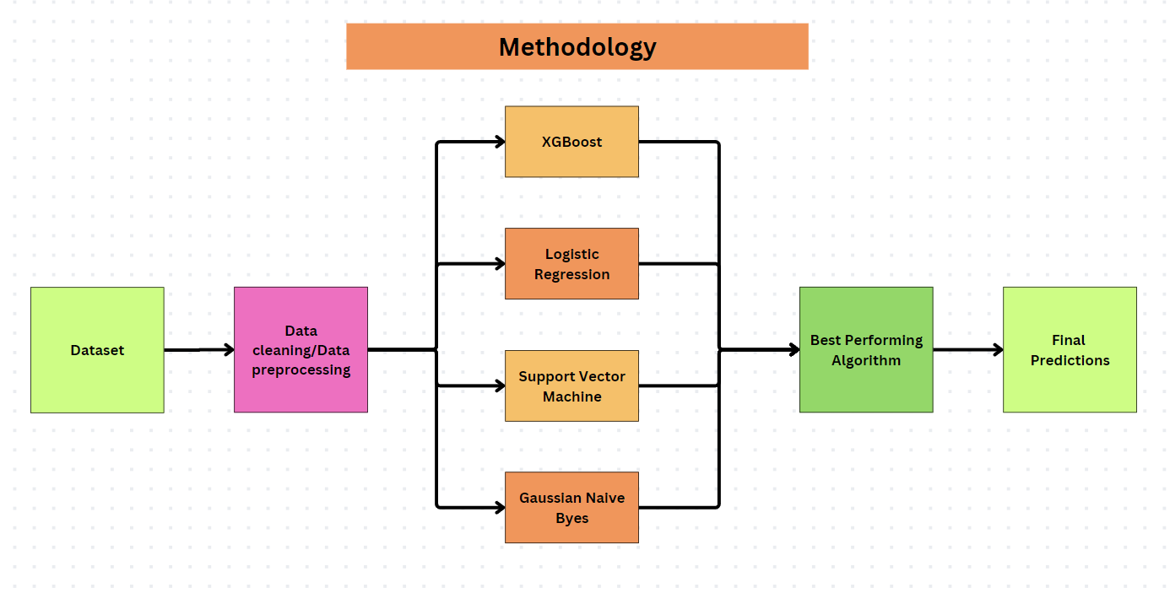

Figure 4:Methodology used.

## 3.4 Model Evaluation:

Following testing, the model's output values and overall performance will be obtained. To assess the model's effectiveness, compare it to other models. Evaluate the performance of machine learning models to determine their strengths and limitations. While accuracy is a popular phrase for describing the performance of a machine learning model, it only applies to classification models. The essential evaluation measures for such models are accuracy, precision, recall, and F1-score. Accuracy is the proportion of correctly classified observations in the total. Precision measures how well the model predicts positives, whereas recall analyzes the model's ability to correctly recognize positive cases. The F1-score provides a balanced measure similar to accuracy.

## 3.5 Predicting Group Matches:

Predicting the outcomes of group matches in football tournaments is a crucial aspect of tournament analysis. This section details the approach and methodology used for predicting group match results, including the steps involved in generating predictions and evaluating their accuracy. Using our test dataset, MainSchedule.csv, the teams were organized into groups ranging from Group A to Group H, with each group consisting of four teams. Within each group, every team will play three matches against the other teams, resulting in a total of six matches per group. The teams will be ranked in a points table based on their match outcomes: a win awards 3 points, a draw awards 1 point to each team, and a loss awards 0 points. This ranking system will be applied to all groups from Group A to Group H, and the points tables for each group will be displayed in the output window.

After predicting the outcomes of group matches, the next step is to determine the group winners based on the match results. Two teams with the highest total points in each group is identified as the group winners. These teams have performed the best in their respective groups and advance to the next stage of the tournament, typically the knockout or playoff rounds.

## 3.6 Proceeding to Knockout Stage:

Proceeding to the knockout stage marks a pivotal moment in any tournament, characterized by heightened stakes and intensified competition. After predicting the outcomes of group matches, the next step is to determine the group winners based on the match results. Two teams with the highest total points in each group is identified as the group winners. These teams have performed the best in their respective groups and advance to the next stage of the tournament, typically the knockout or playoff rounds. The winner of one group will play against the runner up of other group and vice versa. This will be the same for quarter final, semifinal and final.

## 3.7 Deployment:

For this project a Flask framework was used to build a web application that displays the overall accuracy of our machine learning predictions. The web application features a button to predict the tournament winner, and clicking it shows the predicted outcome. Additionally, the app presents the results of each group stage match in a points table, which includes the total number of games played by each team, the number of wins, losses, and draws, and the total points earned by each team. Predictions are also provided for the Round of 16, Quarter Finals, Semi Finals, Final, and Third Place Match.

There is also an another button for predicting the winner between two teams. To make a prediction, users must enter the home team, away team, tournament name, city, and country before clicking the predict button. The software will then generate a forecast of which team is more likely to win between the two.

# Chapter 4. Apparatus-Tools and Technologies used

The software, programming language, and tools/libraries used in this research work are described in detail below.

## 4.1 Data Collection Tools:

Python:

Python programming language served as the primary tool for data collection due to its versatility, ease of use, and rich ecosystem of libraries for web scraping, API access, and data manipulation.

Beautiful Soup: Beautiful Soup library was utilized for parsing HTML and XML documents, facilitating web scraping tasks by extracting relevant data from websites.

Scrapy: Scrapy framework was employed for building web crawlers and spiders to automate the process of extracting data from multiple web pages or entire websites.

Requests: Requests library was used for making HTTP requests to web servers and fetching data from web pages, APIs, or other online sources.

## 4.2 Model Development Tools:

Python:

Python served as the primary programming language for model development due to its extensive libraries for machine learning, data analysis, and numerical computing.

Scikit-learn: Scikit-learn, a widely-used machine learning library in Python, provided a comprehensive set of tools for building, training, and evaluating predictive models, including classification, regression, and clustering algorithms.

XGBoost: XGBoost library was utilized for gradient boosting-based machine learning, offering high performance and scalability for tree ensemble methods, such as gradient boosting decision trees (GBDT).

SVM (Support Vector Machine): Scikit-learn's SVM module was employed for implementing support vector machine algorithms for both classification and regression tasks.

Logistic regression: Logistic regression is imported from sklearn.linear_model library.

Gaussian Naïve Bayes: Gaussian Naïve Bayes model was employed from sklearn.naive_bayes library.

Jupyter Notebooks:

Jupyter Notebooks were used as an interactive development environment for prototyping, experimenting, and documenting the model development process.

JupyterLab: JupyterLab, an integrated development environment (IDE) for Jupyter Notebooks, provided a flexible and intuitive interface for writing code, visualizing data, and analyzing model outputs.

Pandas and NumPy:

The Pandas and NumPy libraries were used for data preprocessing, manipulation, and transformation, including feature engineering, missing value handling, and categorical variable encoding.

Matplotlib:

The Matplotlib library was used for data visualization and exploratory data analysis (EDA), resulting in meaningful plots, charts, and graphs.

Model Evaluation Metrics:

Various metrics and techniques were used to evaluate the performance of the developed models, including accuracy, precision, recall, F1-score.

Cross-Validation:

Cross-validation techniques, such as k-fold cross-validation, were employed to assess the generalization performance of the models and ensure their robustness across different datasets.

Ensemble Methods:

Ensemble methods, including gradient boosting, were explored and implemented to combine multiple base models for improved predictive accuracy and stability.

## 4.3 Deployment Tools:

Flask:

Flask, a lightweight web framework for Python, was utilized for building and deploying the machine learning model as a RESTful API (Application Programming Interface).

Flask provides simplicity and flexibility for creating web applications and APIs, making it suitable for deploying machine learning models in production environments.

# Chapter 5. Results

In this chapter, the results obtained from the predictive models developed for football tournament winner prediction. The aim of this analysis is to evaluate the performance of theXGBoost, Logistic Regression, Support Vector Classifier (SVC) and Gaussian Naïve Bayes classifier in forecasting the outcomes of women’s fifa world cup.

Quantitative Results:

XGBoost algorithm achieves an accuracy score of 70.80% in predicting winner of women’s football worldcup comparing that to random selection where accuracy of correctly predicting the winner would be approx 33.33% (win,lose,draw) .The XGBoost out performs random selection by achieving an accuracy twice as high.The use of historical data has been helpful for XGBoost to make accurate predictions.

The XGBoost algorithm demonstrates the highest accuracy among the four classification algorithm, achieving 70.80% accuracy rate in predicting the winner of women’s fifa world cup.

Logistic Regression also performed reasonably well, achieving accuracy rate of 68%.

Gaussian Naive Bayes and Support Vector Machine algorithms exhibited lower accuracy rates, with 65% and 58%, respectively.

|  |  |  |  |  |
| --- | --- | --- | --- | --- |
| Algorithm | Accuracy | Precision | Recall | F1 |
| XGBoost | 0.708 | 0.696 | 0.757 | 0.696 |
| Logistic Regression | 0.689 | 0.640 | 0.730 | 0.680 |
| Gaussian NB | 0.651 | 0.556 | 0.720 | 0.610 |
| SVM | 0.585 | 0.630 | 0.560 | 0.590 |

Figure 5:Methodology used.

*,*

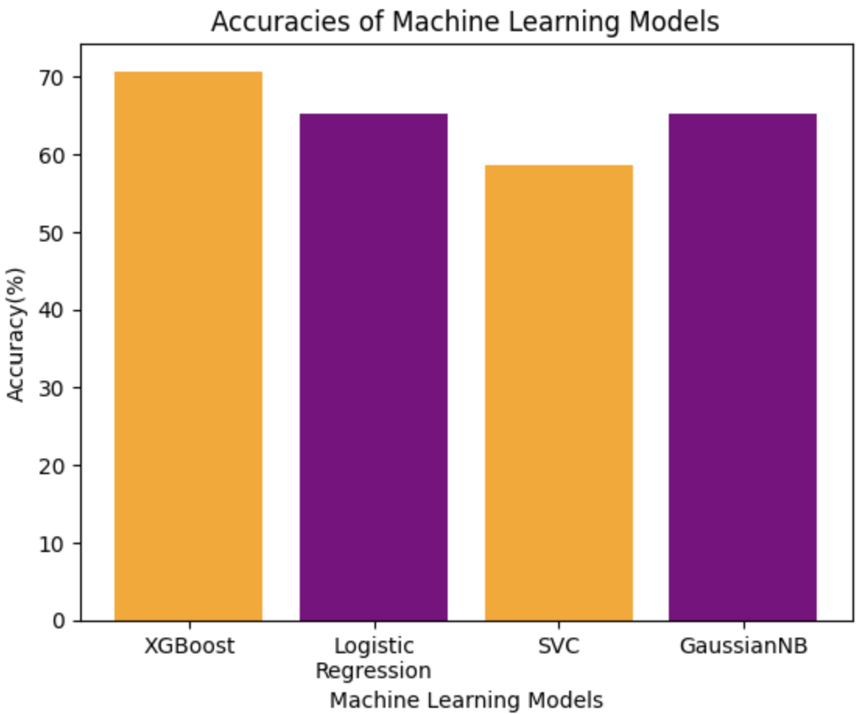

Figure 6:Bar chart for accuracies.

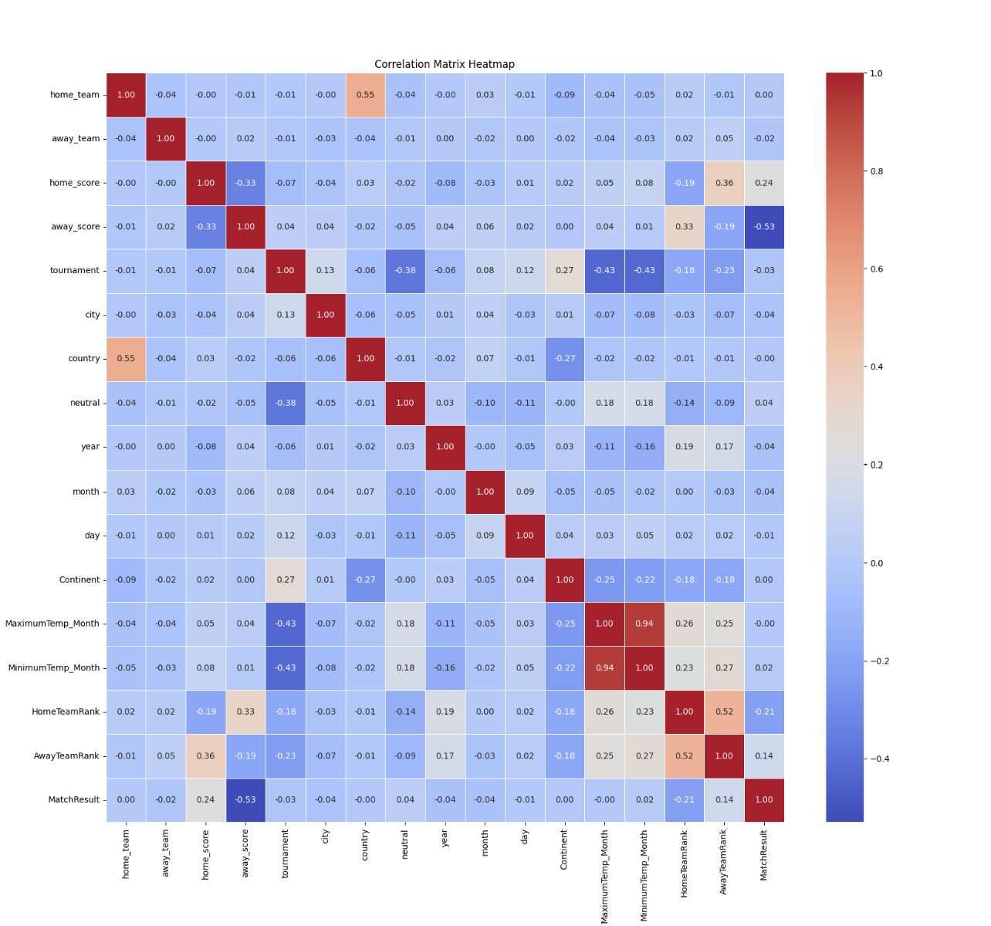

Figure 7:Displaying correlation using heatmap.

Qualitative Results:

From the heat map most of the features have low correlation.All the feature are independent. Despite the lack of correlation, our models, especially XGBoost and Logistic Regression, achieved relatively high accuracy rates. This suggests that even in the absence of simple linear correlations, these algorithms are still capable of handling the dataset. It draws attention to how well these models can represent intricate patterns.

Absence of Strong correlations may indicate that each feature makes a distinct contribution to the prediction task. This diversity suggests that the model is using a wide variety of data to generate predictions, which can be helpful.

User Interface:

World Cup Winner Prediction:

As anticipated the final result of the women's football World Cup. This is the app UI. To view the predicted winner, simply click the "Predict" button beneath the "World Cup Winner Prediction" section.

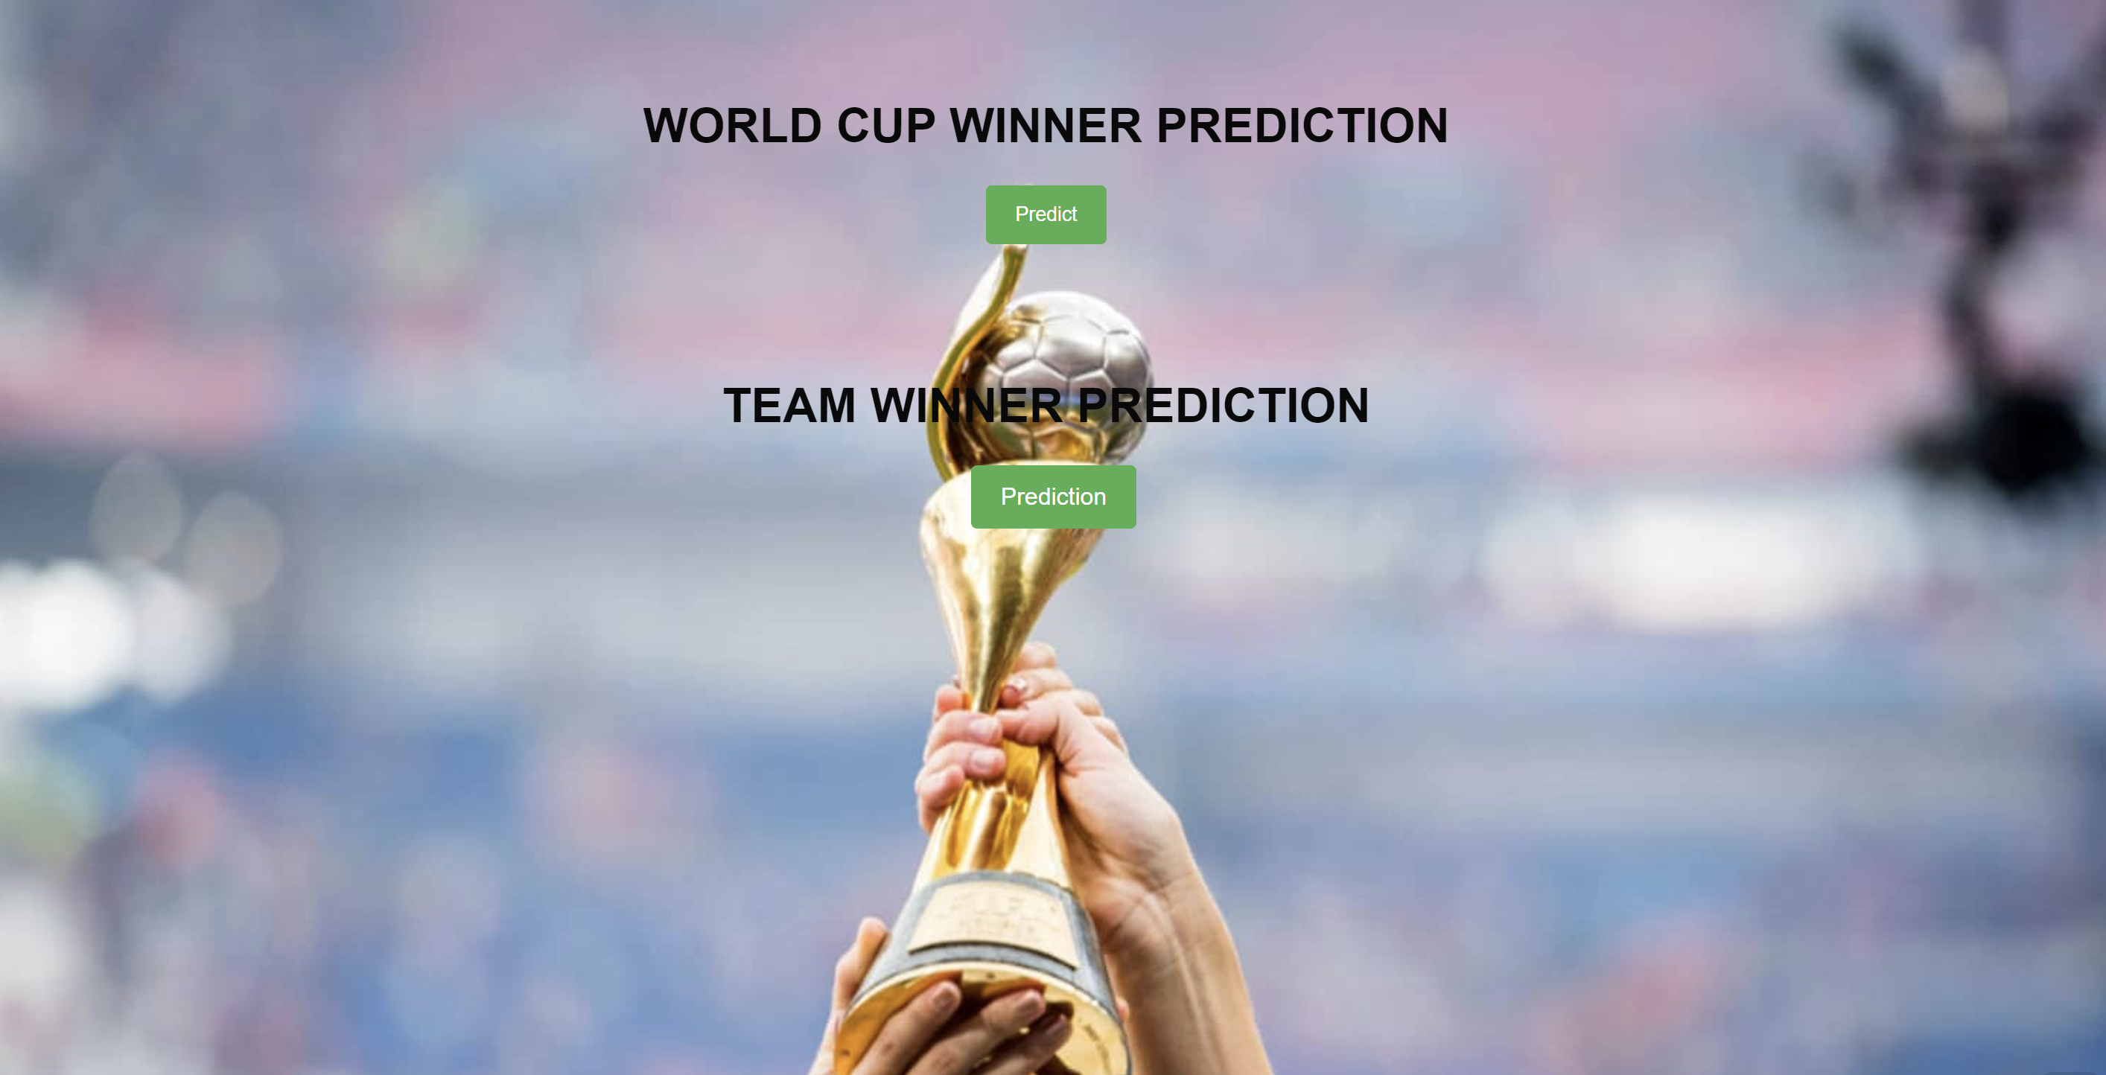

Figure 8:User Interface

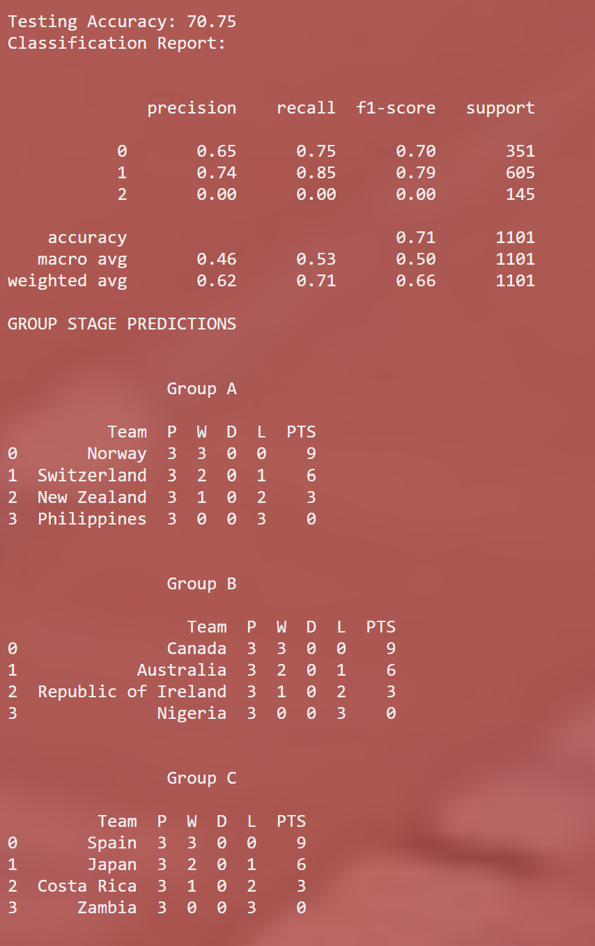

Figure 9:User Interface



Figure 10:User Interface

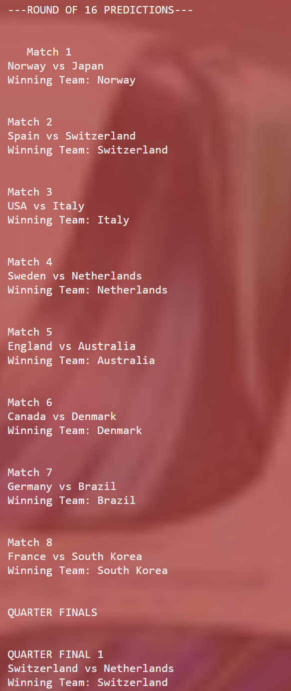

Figure 11:User Interface

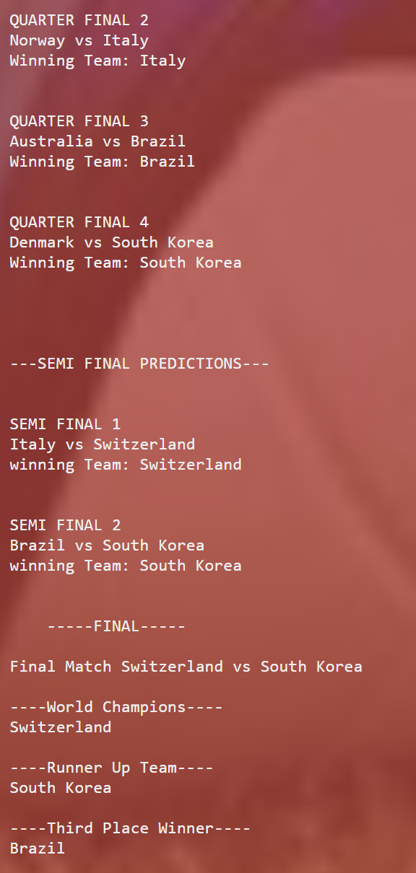

Figure 12:User Interface

The results reflect the standings and point tables for every group. Also predictions from the Round of 16, Quarter Finals, Semi Finals, and Final.According to the predictions, Switzerland is expected to win the World Cup.

Team Winner Predictions

Additionally, an algorithm is integrated for predicting the winner between two teams. To use this feature, select "Team Winner Prediction," which will launch a new window. In this window, input the away team name, home team name, tournament name, city, and country. Then click "Predict." The machine learning algorithm will forecast who will win amongst the two teams.

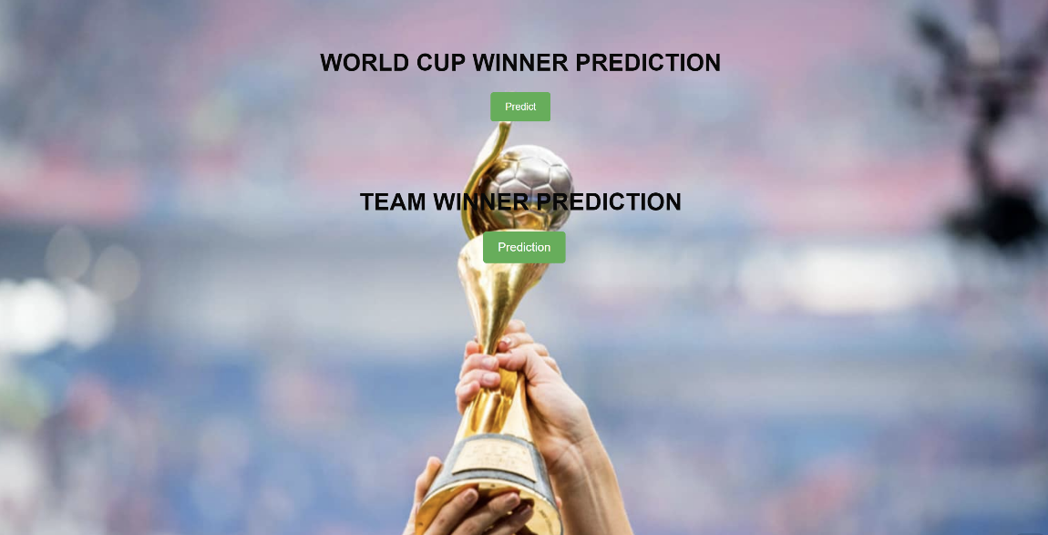

Figure 13:User Interface

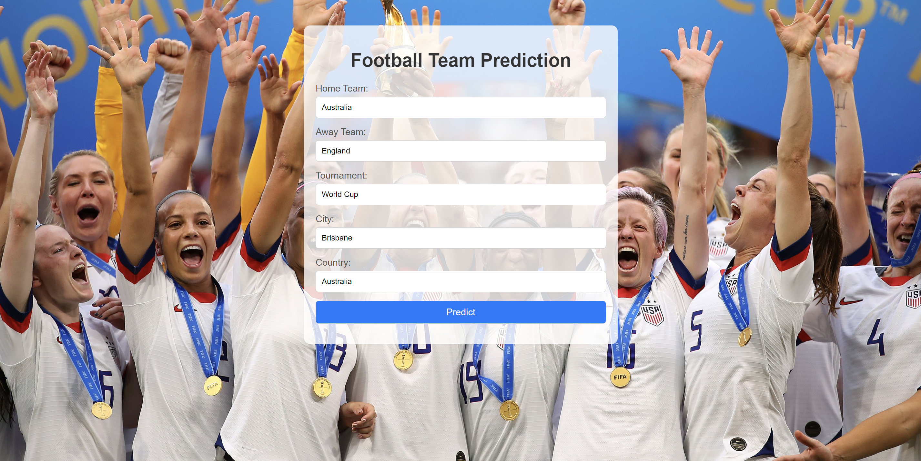

Figure 14:User Interface

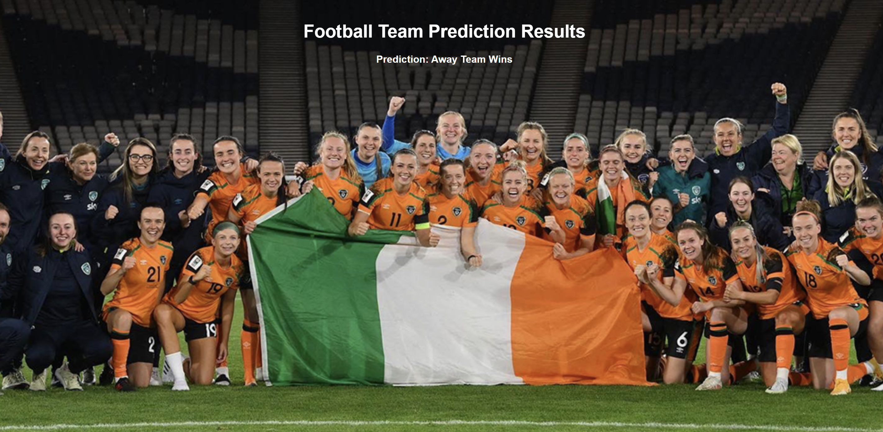

Figure 15:User Interface

# Chapter 6. Conclusion & Future Scope

The project intends to contribute to the advancement of predictive analytics within sports by showcasing the efficacy of machine learning methodologies in predicting the outcomes of women's fifa world cup. Four classification algorithms were used: Gaussian Naive Bayes (GaussianNB), Support Vector Machine (SVM), Logistic Regression, and XGBoost. The findings showed that XGBoost had the highest accuracy of 70.80%, greatly beating the other models. Logistic Regression followed with a 68.9% accuracy, while GaussianNB and SVM achieved 65.1% and 58.5%, respectively. These findings show that XGBoost is the most effective algorithm for this predicting task, successfully capturing complex patterns. Overall, the research illustrates the immense potential of machine learning in sports analytics, notably in predicting tournament outcomes. The high level of accuracy achieved by the models, particularly XGBoost, indicates that past match data includes significant insights that can be used for prediction.

Additionally, Implement of same system could be possible across various sports tournament such as cricket, basketball etc. Real-time data can be implemented to our system in the future to predict real-time outcomes. Additional features like individual player statistic can be included which can help us improve the overall accuracy. Hybrid models can be implemented which combines multiple algorithms to improve the overall accuracy of the prediction.

Additionally, a similar approach can be used in a variety of sports, including cricket, basketball, and others. In the future, real-time data can be incorporated into the system to forecast results in real time. Additional information, such as individual player statistics, can improve the overall accuracy of projections. Furthermore, hybrid models combining different techniques can be created to improve overall forecast accuracy.

At the same time, it is crucial to identify the limitations of this study in order to state the scope of improvement. The study relies on historical match data which may not capture recent trends,change in team performance or emerging player. The predictive models are dependent on the historical dataset which might not include all the features which result in match outcomes. Important features like player injury,team stratergies player form is not considered.

**Reference**

1] Vashist, M., Bahl, V., Sengar, N., & Goel, A. (2022). Machine Learning for Football Matches and Tournaments. In Proceedings of the 2022 International Conference on Machine Learning, Big Data, Cloud, and Parallel Computing (COM-IT-CON). IEEE. [Online] Available: <https://doi.org/10.1109/COM-IT-CON54601.2022.9850673>

2] Syaifudin, Y. W., & Puspitaningayu, P. (2021). Predicting Winner of Football Match Using Analytical Hierarchy Process: An Analysis Based on Previous Matches Data. In Proceedings of the 2021 International Conference on Data Analytics for Business and Industry (ICDABI). IEEE. [Online] Available: <https://doi.org/10.1109/ICDABI53623.2021.9655836>

3] V P, A., D, R., & S Sree Nandha. (2023). Football Prediction System using Gaussian Naïve Bayes Algorithm. In Proceedings of the 2023 Second International Conference on Electronics and Renewable Systems (ICEARS). IEEE. [Online] Available: <https://doi.org/10.1109/ICEARS56392.2023.10085510>

4] Majumdar, A., Kaur, R., Kulkarni, T., Jiruwala, M., Shah, S., & Pise, N. (2022). Football Match Prediction using Exploratory Data Analysis & Multi-Output Regression. In Proceedings of the 2022 IEEE Conference on Interdisciplinary Approaches in Technology and Management for Social Innovation (IATMSI). IEEE. [Online] Available: <https://doi.org/10.1109/IATMSI56455.2022.10119340>

5] Prasetio, D., & Harlili, D. (2016). Predicting football match results with logistic regression. In Proceedings of the 2016 International Conference On Advanced Informatics: Concepts, Theory And Application (ICAICTA). IEEE. [Online] Available: <https://doi.org/10.1109/ICAICTA.2016.7803111>

6] Vashist, M., Bahl, V., Goel, A., & Sengar, N. (2021). Full Time Result Prediction using Ensemble Techniques. *AJCT*, 7(3), 38-42.

7] Farzin, O., Parinaz, E., & Faezeh, S. M. (2013). Football result prediction with Bayesian network in Spanish league-Barcelona team. *International Journal of Computer Theory and Engineering*, 5(5), 812-815.

8] Sujini, G. N., Poornima, B., & Deepika, D. G. (2021). FIFA OUTCOMEPREDICTION USING MACHINE LEARNING TECHNIQUES. *INTERNATIONAL JOURNAL OF APPLICATIONS*, 15(6). Retrieved from <http://www.ijcea.com/wp-content/uploads/2021/06/150601-FIFA-OUTCOme.pdf>

9] Sharma, D., & Sharma, V. (2019). Optimal Predictive Model for FIFA World Cup. *International Journal of Recent Technology and Engineering*, 7(6C).

10] Hosmer, D. W., Lemeshow, S., & Sturdivant, R. X. (2013). *Applied Logistic Regression* (3rd ed.). Hoboken, New Jersey: John Wiley & Sons, Inc.

11] Igiri, C. P., & Nwachukwu, E. O. (2014). An Improved Prediction System for Football a Match Result. *IOSR Journal of Engineering*, 4(12), 12-20.

12] Rajadhyaksha, N. (2021). Modelling Veracity of Football Player Trade Rumours on Twitter Using Naive Bayes Algorithm. In *2021 International Conference on Artificial Intelligence and Machine Vision (AIMV)* (pp. 1-5). Gandhinagar, India.

13] Tang, X., Liu, Z., Li, T., Wu, W., & Wei, Z. (2018). The Application of Decision Tree in the Prediction of Winning Team. In *2018 International Conference on Virtual Reality and Intelligent Systems (ICVRIS)* (pp. 239-242). Hunan, China.

14] Manish, S., Bhagat, V., & Pramila, R. (2021). Prediction of Football Players Performance using Machine Learning and Deep Learning Algorithms. In *2021 2nd International Conference for Emerging Technology (INCET)* (pp. 1-5). Belagavi, India.

15] Azeman, A. A., Mustapha, A., Razali, N., Nanthaamomphong, A., & Abd Wahab, M. H. (2021). Prediction of Football Matches Results: Decision Forest against Neural Networks. In *2021 18th International Conference on Electrical Engineering/Electronics, Computer, Telecommunications and Information Technology (ECTI-CON)* (pp. 1032-1035). Chiang Mai, Thailand.

16] Capobianco, G., Di Giacomo, U., Mercaldo, F., Nardone, V., & Santone, A. (2019). Can machine learning predict soccer match results? In *Proceedings of the 11th International Conference on Agents and Artificial Intelligence (ICAART 2019)* (pp. 458–465).

17] Beal, R., Middleton, S., Norman, T., & Ramchurn, S. D. (2021). Combining machine learning and human experts to predict match outcomes in football: A baseline model. In *AAAI*.

18] Saiedy, S., Qachmas, M., & Amanullah, F. (2020). Predicting epl football matches results using machine learning algorithms. *International Journal of Engineering Applied Sciences and Technology*, 5, 83–91.

19] Randrianasolo, A. S. (2023). Predicting EURO Games Using an Ensemble Technique Involving Genetic Algorithms and Machine Learning. In *2023 IEEE 13th Annual Computing and Communication Workshop and Conference (CCWC)* (pp. 0470-0475). Las Vegas, NV, USA.

20] Jain, S., & Kaur, H. (2017). Machine learning approaches to predict basketball game outcome. In *2017 3rd International Conference on Advances in Computing, Communication & Automation (ICACCA) (Fall)* (pp. 1-7). Dehradun, India.

21] Sikka, D., & D, R. (2022). Basketball Win Percentage Prediction using Ensemble-based Machine Learning. In *2022 6th International Conference on Electronics, Communication and Aerospace Technology* (pp. 885-890). Coimbatore, India.

22] Abhishek, C. S., Patil, K. V., Yuktha, P., Meghana, K. S., & Sudhamani, M. V. (2019). Predictive Analysis of IPL Match Winner using Machine Learning Techniques. *Int. J. Innov. Technol. Explor. Eng.*, 9(2S), 430-435.

23] Yasir, M., Chen, L. I., Shah, S. A., Akbar, K., & Sarwar, M. U. (2017). Ongoing Match Prediction in T20 International. 17(11), 176-181.

24] Passi, K., & Pandey, N. (2018). Increased Prediction Accuracy in the Game of Cricket Using Machine Learning. *Int. J. Data Min. Knowl. Manag. Process*, 8(2), 19-36.

25] Kampakis, S., & Thomas, W. (2015). Using Machine Learning to Predict the Outcome of English County twenty over Cricket Matches. Retrieved from <http://arxiv.org/abs/1511.05837>.

26] Pathak, N., & Wadhwa, H. (2016). Applications of Modern Classification Techniques to Predict the Outcome of Cricket. *Procedia Comput. Sci.*, 87, 55-60.